**Lesson 4 Demo 8**

**Creating Multi Container Pods**



Steps to be followed:

1. Creating a multi container Pod using configuration file

**Step 1: Creating a Multi container Pod using configuration file**

1. Navigate to the deployments folder:

***cd deployments***

1. Create a pod configuration yaml file like below:

***vi multicontainerpod.yaml***

1. Copy the following code in the yaml file:

***apiVersion: v1***

***kind: Pod***

***metadata:***

***name: multicontainer-pods***

***namespace: facebook***

***labels:***

***app: httpd***

***tier: frontend-backend***

***version: v1***

***spec:***

***containers:***

***- name: web***

***image: httpd***

***ports:***

***- containerPort: 80***

***- name: db***

***image: postgres***

***ports:***

***- containerPort: 5432***

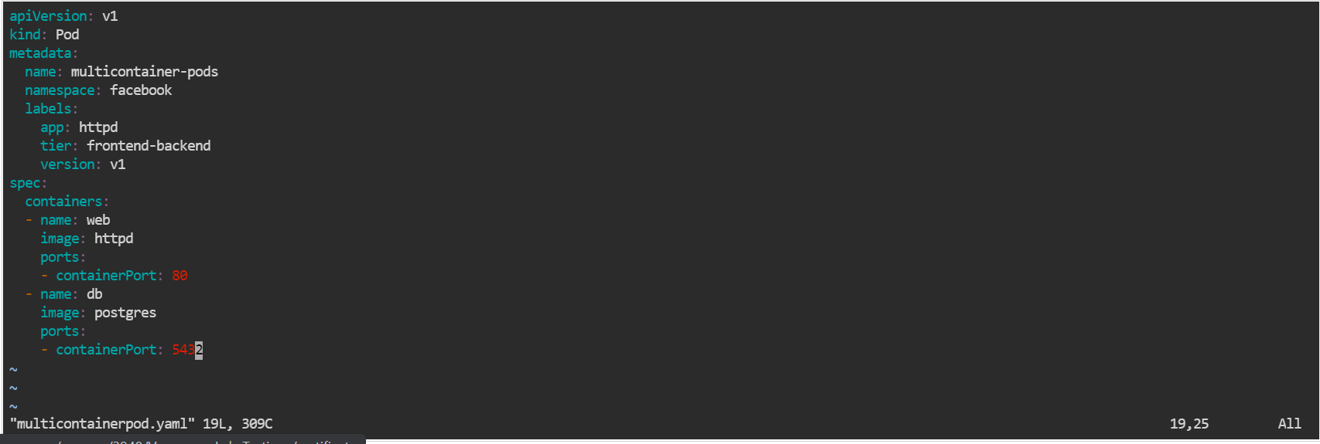

| **Note:** Press the **esc** button and type **:wq** to save and exit the file. |
| --- |

1. Create a namespace, if not present, using the below command (Optional):

***kubectl create namespace facebook***

1. Enter the command to create multi container pod:

***kubectl create -f multicontainerpod.yaml -n facebook***



1. Enter the command to check the status:

***kubectl get pods -A -o wide***

